**24)**

**Aim:** To Design Deterministic Finite Automata using simulator to accept the string having ‘ab’ as substring over the set {a,b}.

**Diagram:**

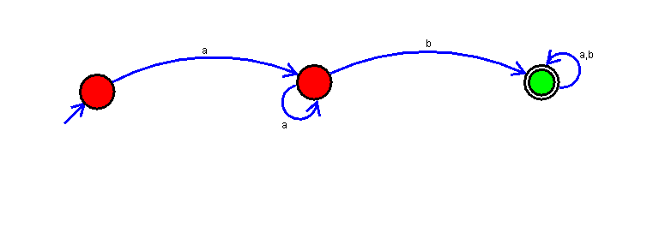

**Result:**

Thus, successfully executed Deterministic Finite Automata using simulator to accept the string having ‘ab’ as substring over the set {a,b}.